Oxidation─Reduction

Ques(01 ) Define oxidation reaction and reduction reaction according to classical concept with suitable examples.

Ques(02 ) Define oxidation reaction and reduction reaction according to modern/electronic concept with suitable examples.

(1).Oxidation reaction:
(i).Classical concept: The reaction in which oxygen or any other electro-negative molecule/ anion added or hydrogen or any other electro-positive molecule/cation eliminated is called oxidation reaction.
Exam:(i). C+O₂→CO₂ , 2H₂+O₂→2H₂ O (O -addition)
(ii). 2Na+Cl₂→2NCl , 2FeCl₂+Cl₂→2FeCl₃ (Cl -addition)
(iii). Zn+H²SO⁴ → ZnSO⁴ + H₂ (SO4^{2─} -addition)
(iv). 4HCl+MnO² → MnCl²+Cl²+2H²O (H -elimination)
(v). 2K⁴Fe(CN)⁶+Cl² →2K³Fe(CN)⁶ + 2KCl (k⁺ -elimination)
(ii). Electronic concept:(Oxidation/De-electronation reaction)
Oxidation is a reaction in which an atom or an ion loses one or more electron(s) and thus increases it’s valancy.
i.e., in oxidation, the atomic/ionic system losses one/more electron(s) and is changed into more electro-positive/less electro-negative state.

Exam:(i). Na − e → Na⁺
(ii). K − e → K⁺
(iii). Mg − 2e → Mg²⁺
(iv). Fe²⁺ − e → Fe³⁺
(v). Cl⁻ − e → Cl

Reduction Reaction:
(i)Classical concept: The reaction in which hydrogen or any other electro-positive molecule/cation added or oxygen or any other electro-negative molecule/anion eliminate is called reduction reaction.
Example: (i). Cl²+H² → 2HCl
(ii). Cl²+2Na → 2NaCl
(iii). Cl²+NH⁴⁺ → NH⁴Cl
(iv). CuO+C → Cu+CO
(v). 2FeCl³+SnCl² → 2FeCl²+SnCl⁴
(vi). CuSO⁴+Zn → Cu+ZnSO⁴
(ii). Electronic concept:(Reduction/Electronation reaction)
Reduction is a reaction in which an atom/ion gains one/more electrons and thus decreases it’s valancy.
i.e., in reduction the atomic/ionic system gains one/more electrons and is changed into less electro-positive/more electro-negative state.
Examples: (i). Cl+e─ → Cl─
(ii). O+2e─ → O_{2─}
(iii). Fe₃₊+e─ → Fe₂₊
(iv). Na₊+e─ → Na
(v). Sn₄₊+2e─→ Sn₂₊

Ques(03 ) Define Oxidizing agent (Oxidant ) and Reducing agent (Reductant) according to classical concept with suitable examples.

Ques(04 ) Define Oxidizing agent (Oxidant ) and Reducing agent (Reductant) according to modern/electronic concept with suitable examples.

Oxidizing agent (Oxidant):
(i). Classical concept: An oxidizing agent (atom/ion/molecule) is that substance which oxidizes some other substance and is itself reduced to a lower valency state by gaining one/more electrons.
(ii). Electronic concept: An oxidizing agent (atom/ion/molecule) is that substance which gains one/more electrons from other species.
Example: F², Cl², Br², I², O², HNO³, conc.H²SO⁴, KMnO⁴, K²Cr²O⁷, peroxides and per-oxi-acids.
Reducing agent (Reductant):
(i). Classical concept: A reducing agent (atom/ion/molecule) is that substance which reduces some other substance and is itself oxidised to a higher valency state by losing one/more electrons.
(ii). Electronic concept: A reducing agent (atom/ion/molecule) is that substance which loses one/more electrons to other species.
Example: Alkali metals, Alkaline earth metals, H², C, CO, H²S, SO², HI, SnCl², H²C²O⁴, Oxi-acids and their salts.

Ques(05). With suitable example, show/explain – “Oxidation and Reduction occurs together”- based on classical concept.

Ans: Consider a chemical reaction
2FeCl₃ + SnCl₂ → 2FeCl₂ + SnCl₄
At the initial state, every Fe atom contained three Cl atoms. After reaction every iron atom contains two Cl atoms. That means elimination of negative Cl atoms occurs. So, FeCl₃ is reduced here.
On the contrary, before reaction every Sn atom contained two Cl atoms. After reaction every Sn atom contains four Cl atoms. That means addition of negative Cl atoms occurs. So, SnCl₂ is oxidized here.
Finally, we can say that in the above reaction- “Oxidation and Reduction occurs together”.
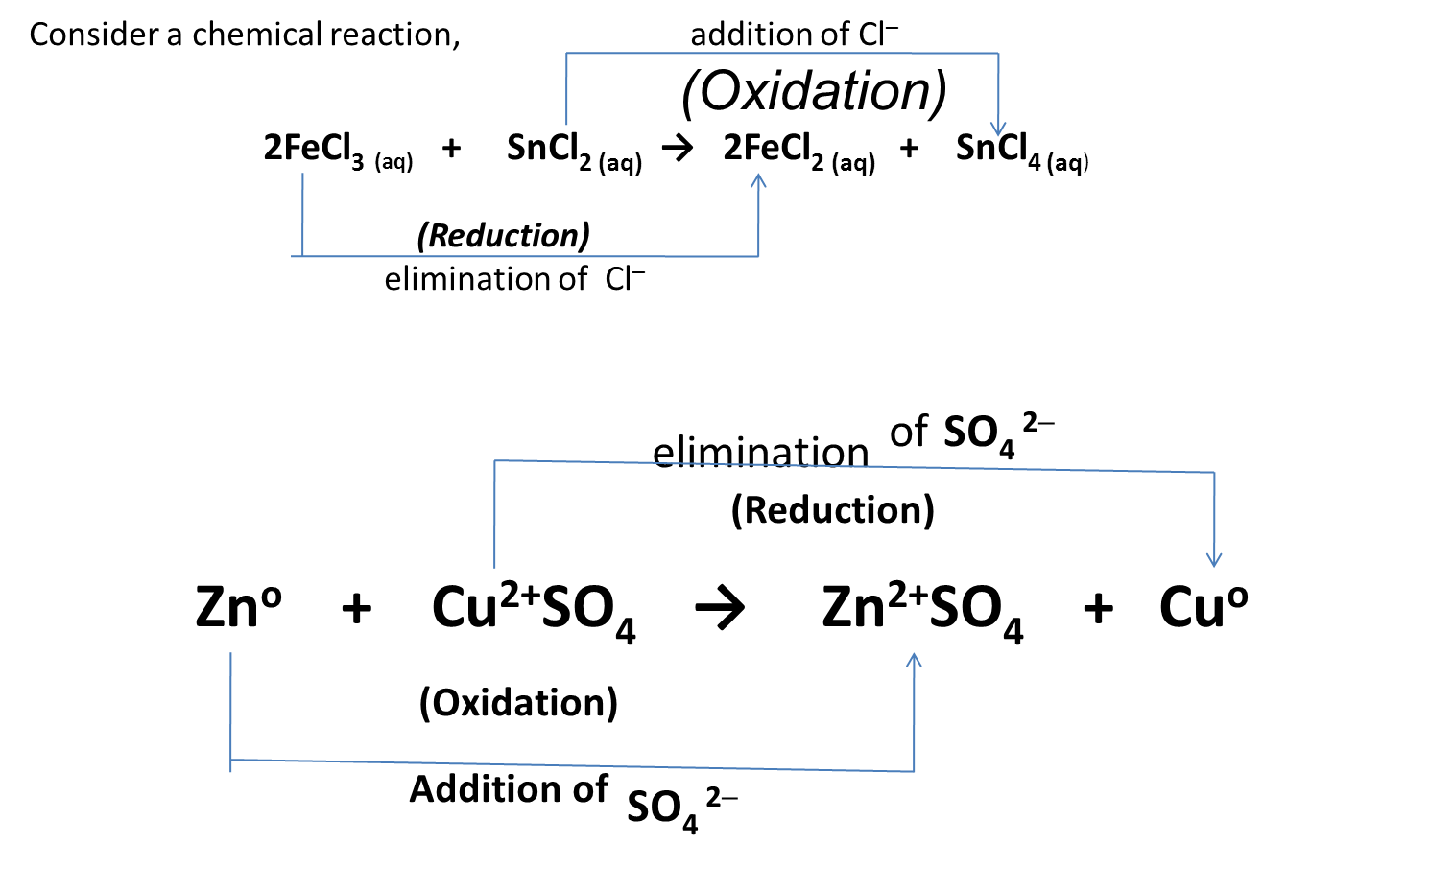

Ques(05). With suitable example, show/explain – “Oxidation and Reduction occurs together”- based on modern/electronic concept.
According to electronic concept, oxidation is a reaction in which an atom/ion loses one/more electron(s). On the contrary, reduction is a reaction in which an atom/ion gains one/more electron(s) and thus decreases it’s valency.
Consider a reaction,
2Na ─ 2e─ → 2Na₊ (Oxidation)
Cl² +2e─ → 2Cl─ (Reduction)
2Na + Cl₂ → 2NaCl (Oxidation-Reduction/REDOX)
Similarly,
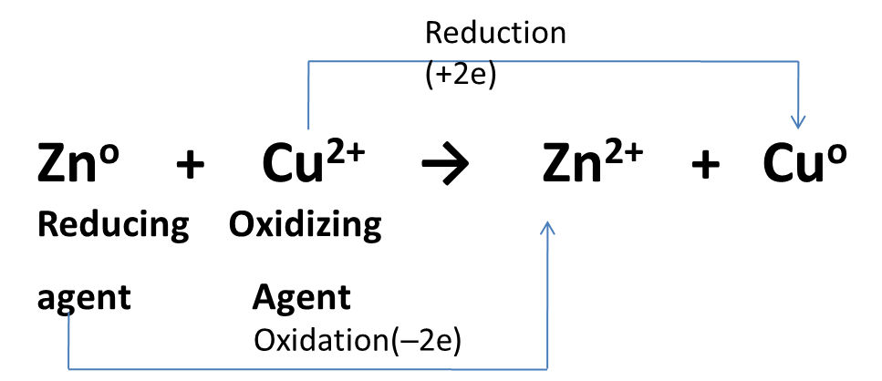

Ques( 06). In the given reactions, indicate –(i) Oxidation, (ii) Reduction, (iii) Oxidizing agent, (iv) Reducing agent.
(i). 2FeCl³ ^{(aq)} + SnCl^{2 (aq)} → 2FeCl² ^{(aq)} + SnCl^{4 (aq)}
(ii). 3Fe + 4H²O → Fe³O⁴ + 4H²
(iii). Zn + CuSO₄ → ZnSO₄ + Cu

Ques( 07). Define the following terms: –(i) Valency, (ii) Oxidation number, (iii) Oxidation state, (iv) REDOX -reaction.

(i). Valency/Covalency: Covalency of an element represents- (i). The number of H- atoms with which an atom of that element can combine, (ii). The number of single bonds which an atom of that element can form, (iii). The number of electrons it’s atom is able to share with other element.
Example: Covalency of “N” in NH₃ is 3
(ii).Oxidation number: The formal charge which an atom of that element appears to have when electrons are counted.
Oxidation number number of an atom may be positive/negative.
Example: O.N. of “K” and “Br” are +1 and ─1 respectively.
O.N. of “N” in NH3 is ─3.

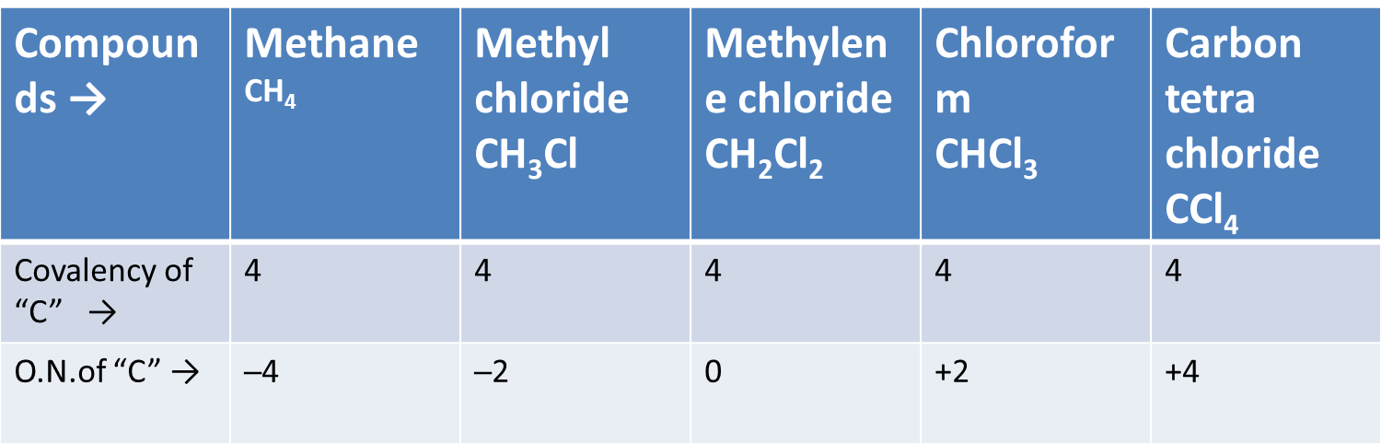

Ques( 08). Write down the differences between Valency and Oxidation number.

Difference between Valency & Oxidation number
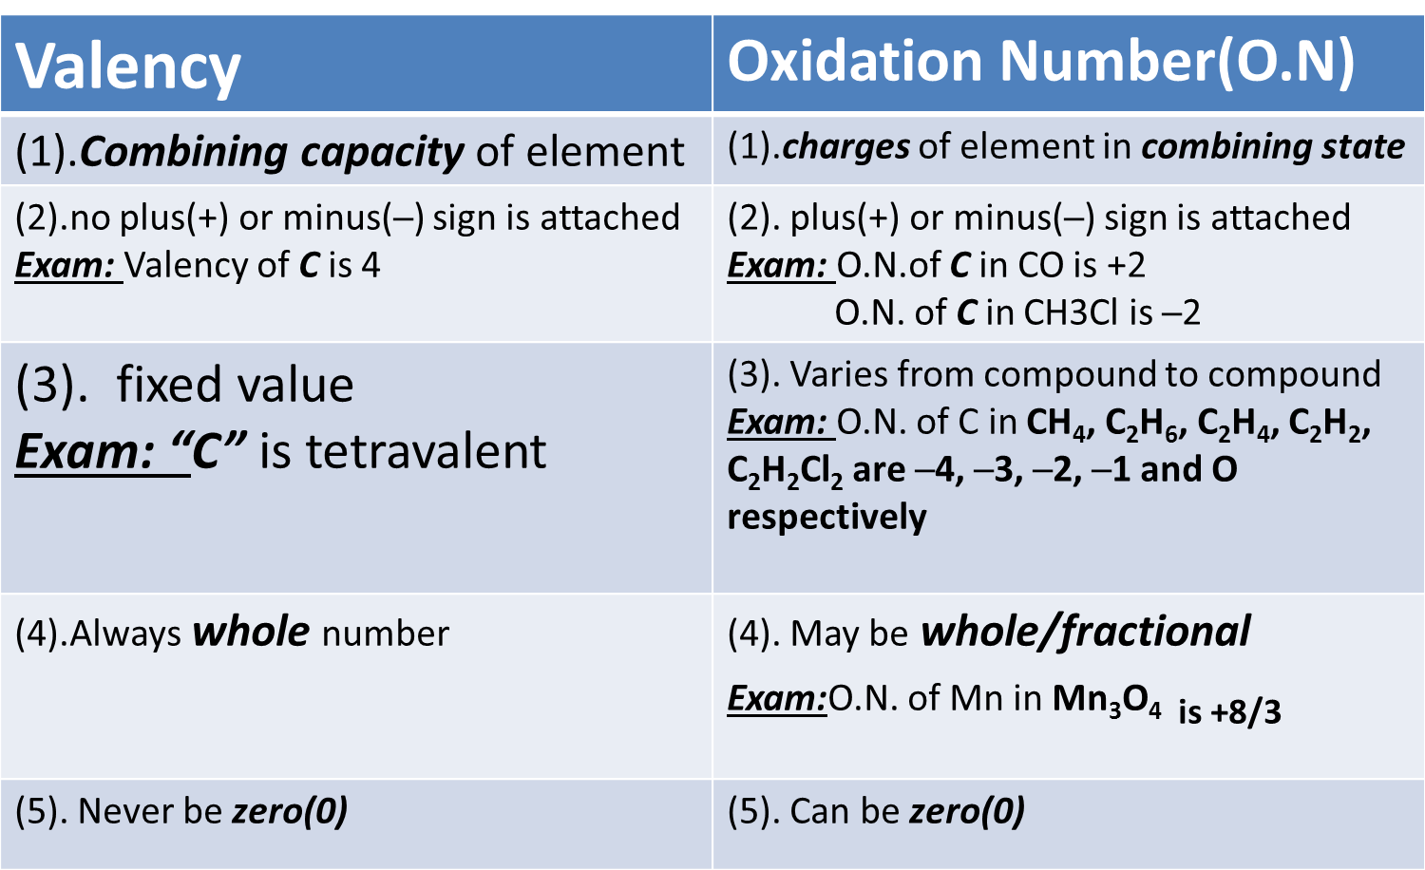

(iii)Oxidation state: In ionic compounds the oxidation state of an element is the same as the charge on the ion formed from the atom of the element.
Example: In KBr , “K” is said to be +1 oxidation state,
while “Br” is said to be ─1 oxidation state.
Oxidation state of element is it’s oxidation number of per atom.
Exam: The oxidation state of “Al” in Al₂O₃ is +6/2= +3

(iv). REDOX-reaction:
Since loss/gain of electrons are relative terms. The loss/gain of electrons takes place simultaneously in a chemical reaction. Thus the oxidation (i.e., loss of electron) and reduction (i.e., gain of electron) reactions go hand in hand and such reactions in which oxidation and reduction take place simultaneously are known as oxidation-reduction reaction or REDOX reaction.
Example: Zn + CuSO₄ → ZnSO₄ + Cu

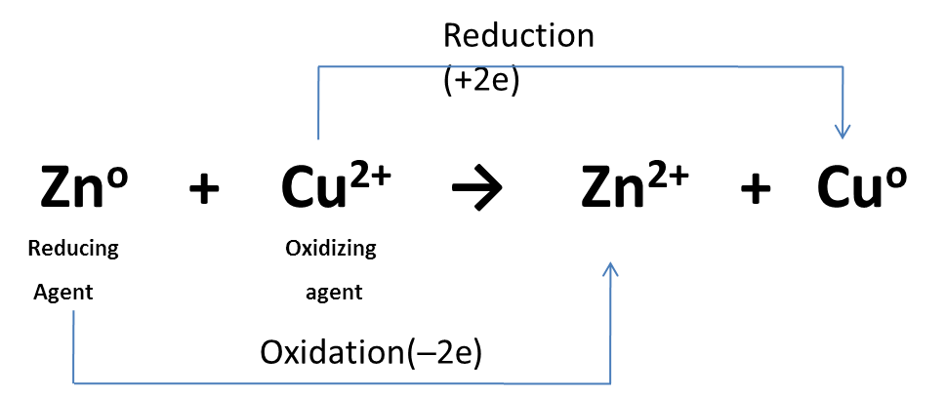

Ques(09). Mention/Calculate the oxidation number of sulfur(S) atom in the following species:-
(i). SO³₌ , (ii).S²O³₌ , (iii).S⁴O⁶₌ , (iv).H²SO⁴ , (v).S²Cl² , (vi).H²S²O² , (vii).H²S²O⁶ , (viii).S²O⁷₌ , (ix).HSO³F , (x).Na²S²O³

Ques(10). Determine/Mention the oxidation number of chromium(Cr) atom in the following species:-
(i).CrCl², (ii).Cr(CO)⁶, (iii).CrO²Cl²,(iv).K²Cr²O⁷, (v).CrO³, (vi).Cr²O⁷₌, (vii).CrO⁴₌

Ques(11 ). Calculate/Determine the value of oxidation number(O.N):
(i).P in PO⁴_{3─}, (ii).Fe in Fe²O³, (iii).Ba in BaF², (iv).C in CO², (v).Cl in ClF³, (vi).O in OF², (vii).Xe in XeOF², (viii).I in IF⁷, (ix).N in NH³, NO, NO², (x).P in PH³, P²O⁵, H³PO⁴, H³P²O⁷─

Ques(12 ). How many electron(s) are lost per molecule of ethyl alcohol when it is oxidized to acetic acid ?

Ques(13 ). What do you understand by EMF and EMF-series?Describe the essentiality of this series for a chemical reaction.
Or, Write a note of EMF series/ Electromotive series. What is the utility of EMF series?
Electromotive Force (EMF):
The flow of electrons taking place in the two half reactions of an electrochemical cell is known to occur in a specific direction. The voltage of the cell is read by the voltameter and is called electromotive force (e.m.f) of the cell.
The standard e.m.f of a given cell (E°_{cell}) is equal to the difference of the standard reduction potential of the cathode (i.e., right hand electrode) ; E°_{cathode} and the standard reduction potential of mthe anode (i.e., left hand electrode); E°_{anode}.
Thus- E°_{cell} = E°_{cathode} − E°_{anode}
= E°_{right} − E°_{left}

Electromotive series/ Electrochemical series/EMF series:
The list of elements or ions arranged in the decreasing order of their standard reduction potential value is called electrochemical or electromotive series or e.m.f series or activity series.
(i). The forward reaction shown in the central column of the series is a reduction reaction and hence the standard electrode potential values are standard reaction values.

(ii). The value of standard reduction potential (E° values) are decreasing as we proceed from F₂/2F⁻ (E° = + 2.85v) to Li⁺/Li (E° = −3.04 v) through 2H⁺/H₂ (E°= ± 0.00 v ). Thus E° values are decreasing from top to bottom in the series.

(iii). With the decrease of E° values from + 2.85v (F₂/2F⁻) to −3.04 v (Li⁺/Li), the oxidizing power of the oxidizing agent is decreasing from top to bottom ( i.e., from F₂ to Li⁺ion ) while the reducing power of the reducing agent is increasing in the same direction.

Essentiality/Uses/Utility of EMF series:
(i). To compare the oxidizing and reducing power of metals or non-metals.
(ii). To know electropositive character of metals.
(iii). To predict the relative chemical reactivity of metals.
(iv). To predict whether a given metal will displace another metal from aqueous solution of it’s salt.
(v). To predict whether a given non-metal will displace another non-metal from aqueous solution of it’s salt.
(vi). To predict whether a given metalwill liberate hydrogen gas from dil. Acid or not.
(vii). To predict whether a given metal can liberate hydrogen gas from water.
(viii). Decomposition of oxides of metals.
(ix). To calculate the emf of a given galvanic galvanic cell.
(x). To predict whether a given galvanic cell will work or not.
(xi). REDOX reaction is likely to occur or not.

Ques(14). Point out the rules followed for balancing a REDOX-reaction by the “ion-electron method”.

Ion-electron method (by the use of half –reaction):
This method was developed in 1927 by Jatte and LaMer and various steps involved in the method are as follows:
(i). Break up the complete equation in two half reactions. One for the change undergone by the reducing agent and the other for the change undergone by the oxidizing agent.
(ii). Balance each half reaction as to the number of atoms of each element. For this purpose:
→(a).Balance the atoms other than H and O for each half-reaction by using simple multiples.
→(b).In neutral and acid solutions, H²O and H₊ are add for balancing O and H atoms. First balance the O atoms. For each excess O atom on one side of the equation, add one H²O to the other side. Now use H₊ to balance H atoms.
In alkaline solutions, OH─ may be used. For each excess OH─ ion in one side, balancing is secured by adding one H²O to the same side and 2OH─ ion to the other side. If hydrogen is still
Unbalanced, balance is secured by adding one OH─ ion for each excess H on the same side as the excess and one H²O to the other side
(iii).Equalize the charges on both sides by adding electrons to the side deficient in negative charges.
(iv).Multiplying one/both half reactions by a suitable number so that on adding the 2 equations, the electrons are balanced.
(v).Add the 2 balanced half-reactions and cancel any terms common to both sides. Also see that all electrons cancel.

Ques(15). Write the rules for balancing REDOX- reaction by “oxidation-nuber method”.

Oxidation-number method:
This method is based on the principle that any increase in oxidation number must be compensated by a decrease. This method consists of the following steps:
Step-(I).Assign oxidation number of atoms undergoing oxidation & reduction and write separate equations for such atoms only.
Step-(II).Add electrons on right side for oxidation and on the left side for reduction. The number of electrons added in each case should be equal to the charge in oxidation number
Step-(III).Balance the number of electrons in 2 equations and add the 2 equations to cancel out electrons.
Step-(IV).Then write the complete equation in it’s original form taking the co-eficients of the oxidants & reductant in step-II. Balance other atoms.
Step-(V).In acid medium, if “O” remains imbalanced, add H²O on the side deficient in “O”. If “H” still remains imbalanced then add H₊ on the required side. Be sure that all atoms and charges are balanced in the final equation.
Step-(VI).In basic medium, if “O” remains unbalanced, then add same number of H²O as the unbalanced atoms on the side with excess and add double the number of OH─ ion on the other side. This will balance oxygen.
In basic medium, if “H” remains unbalanced, then add same number of OH─ ion as the difference on the side with the excess H and add same number of H²O on the other side.
Be sure that all the participants and charges are balanced in the final equation.

Ques(16). Complete and balance the following REDOX-reaction by the “ion-electron method”.
(i). MnO₂ + NaCl + … → MnSO₄ + Cl₂ + …. + ….
(ii). K₂Cr₂O₇ + KI + … → I₂ + Cr₂(SO₄)₃ + … …
(iii). KMnO₄ + H₂Cr₂O₄ + … → CO₂ + MnSO₄ + …
(iv). Br₂ + KOH → KBr + KBrO₃ + … …
(v). Na₂S₂O₃ + I₂ → Na₂S₄O₆ + NaI
(vi). PbS + H₂O₂ → PbSO₄ + H₂O
(vii). CuSO₄ + KI → Cu₂I₂ + K₂SO₄
(viii). KMnO₄ + H₂C₂O₄ + … → K₂SO₄ + MnSO₄
(ix). 2CuSO₄ + … … → Cu₂I₂ + I₂
(x).FeSO₄ + KMnO₄ + … → Fe₂(SO₄)₃ + … …

Ques(17). Complete and balance the following REDOX-reaction by the “oxidation-number method”.
(i). CuO + NH₃ → Cu + N₂ + H₂O

Math Problems (Oxidation& Reduction):
Prob(01). How much gram of K²Cr²O⁷ is required to oxidize completely 5 gm of dry and pure ferrous sulfate (FeSO⁴)?
Prob(02). 25 ml H²O² is oxidized by 15 ml 0.3 M KMnO⁴ with dil. H²SO⁴ . What is the molar concentration of H²O².

